3.37: a) The speed relative to the ground is 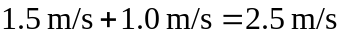, and the time is 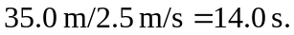 b) The speed relative to the ground is 0.5 m/s, and the time is
70 s.

